BLM 7 Student Resource
Grade 4/5, Diminishing Perspective
Techniques in Diminishing Perspective: Showing Objects as Near or Far
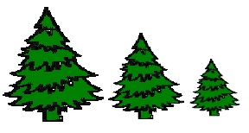  Varying the size of object:  Near objects are larger,  Far objects are smaller | 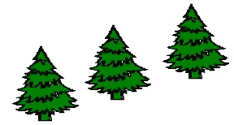  Varying the placement:  Near objects are lower,  Far objects are higher
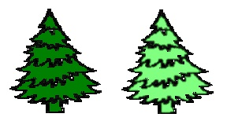  Varying the colour value and intensity:  Near objects are darker and sharper in colour,  Far objects are lighter and less intense | 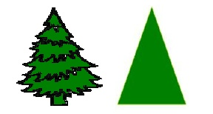  Objects are the same size  and occupy the same space
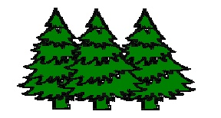  Overlapping:  Near objects are in front,  Far objects are behind | 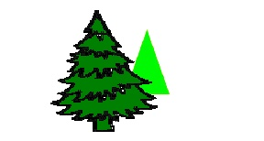  Near objects are larger, lower on the page, darker, more detailed, and sharper in colour. Far objects are smaller, higher on the page, less detailed, and less intense in colour.

