BLM 5A Teacher Resource
Grade 5, Estimating the Costs of Art Supplies

Big Kids Choice Brush Set Shader
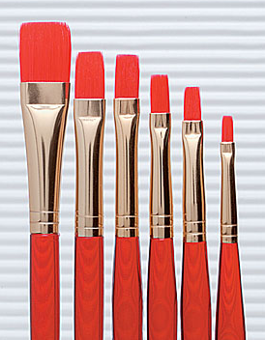
These brushes feature brightly-coloured translucent acrylic handles that are short and thick for comfortable and easy grip. Quality taklon bristles provide fine points, sharp edges, and resilient spring. Colour-coded to show distinctive head shapes. Includes one 0.32 cm (1/8”), three 0.63 cm (1/4”), one 0.93 cm (3/8”), and one 1.56 cm (5/8”).
Big Kids Choice Brush Set Shader
6-piece set. Cost $6.30 each

PRANG Peel-off Charcoal Pencils
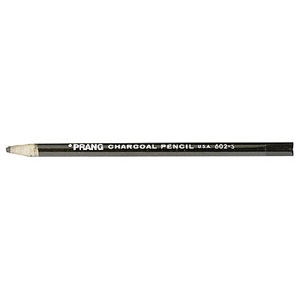
Paper covered, self-sharpening with pull string. These charcoal pencils are made of selected charcoal, finely ground and free of all grit and impurities. Highly compacted and uniformly smooth.
PRANG Charcoal Pencils - 12-Pack
Soft. Cost $9.55 each

Crayola Wax Crayons
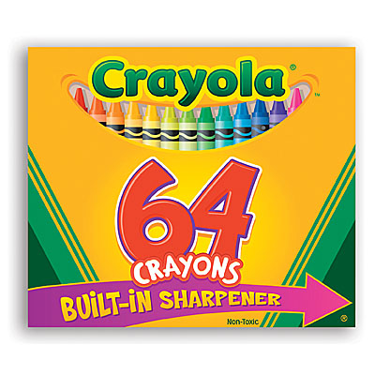
The standard of the industry for over 50 years. Noted for their cleanliness, compactness, permanency, and waterproof properties - remain firm and will not bend from the user’s hand. Colours are true and in perfect relation to each other. Blend smoothly on paper, cardboard, wood, or fabrics. All sticks measure 9.05 cm x 0.78 cm (3 5/8” x 5/16”), paper-wrapped. Non-toxic.
Crayola Wax Crayons, Box of 64
Cost $6.80 each

Crayola Colour Classic 8-Colour Markers
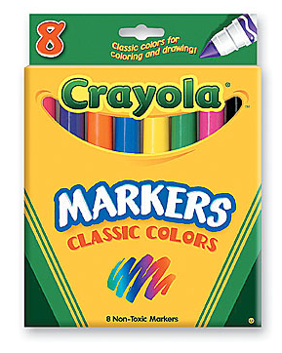
Specially-designed, non-toxic watercolour markers available with a large conical tip for drawing fine lines or broad strokes; or a thin-line tip for drawing, outlining, and writing. Special nib allows maximum colour without penetrating paper. Revive dried-out tips easily in warm water.
Crayola Colour Classic 8-Colour Markers, Conical-Tip
Cost $4.45 each

All Crayola Pack - Classpack
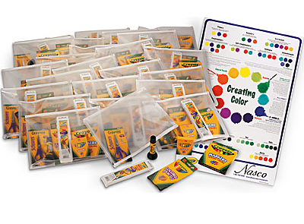
The standard of the industry for over 50 years! Get the necessary art supplies that young students need with a brand that everyone can rely on. Includes box of 16 crayons; set of eight conical-tip classic color markers; 5 pointed tip children’s scissors; 0.88-oz. washable glue stick that goes on blue but dries clear; 8-color oval pan watercolor set; set of 12 colored pencils; and 9 x 12 PolyZip Envelope. For individual use. Comes with 24 of each item listed above and bonus Crayola Creating Color Poster.

All Crayola Pack – Class pack, enough materials for a class or group of 24
Cost $536.70 each

Above Ground Art Supplies On-line Store - Brushes & Painting Accessories - Brushes - Brush Sets

