BLM 1 Student Resource
Grade 8, Guess the Sale Price
ARTWORK | HINTS | Price
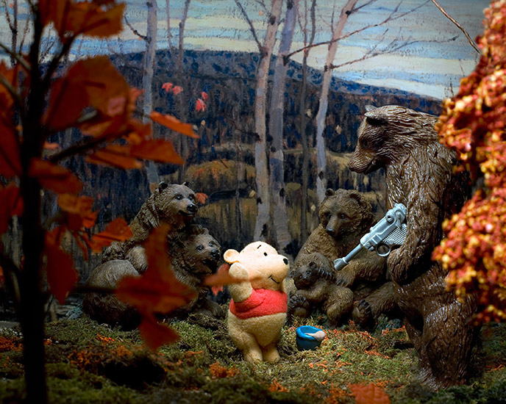 | One of Top 10 Exhibitions of 2008 at the McMichael Gallery  Winnipeg artist, and photographer  Imaginary scenes of dolls and toys with art backgrounds
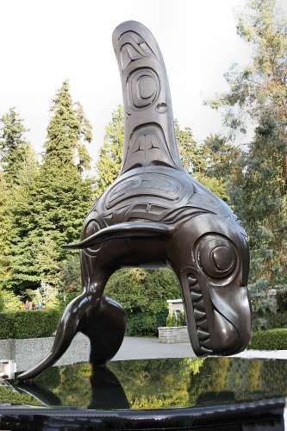 | BC artist  Natural & mythological worlds  Indigenous artist
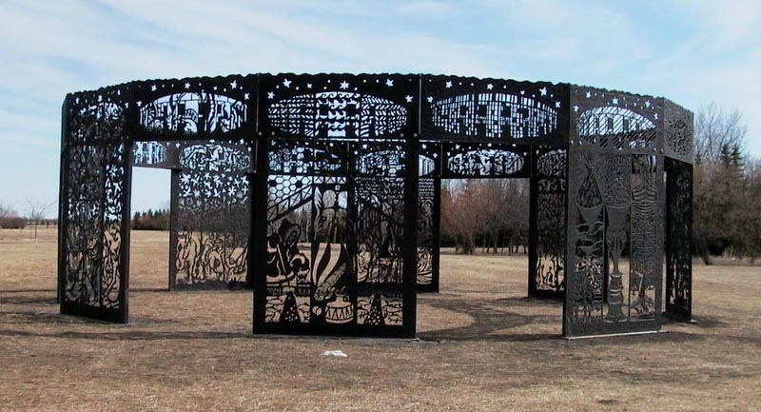 | From Saskatchewan  Sculptures on Canadian postage stamps  His bronze cows are at the TD Centre in Toronto
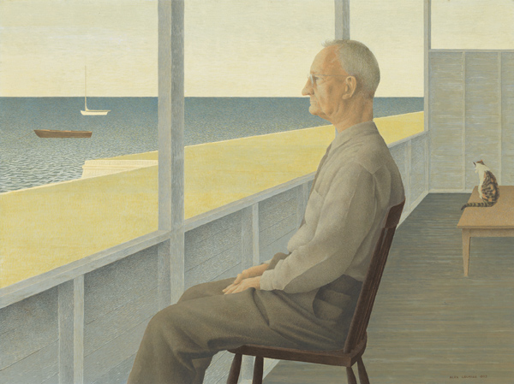 | Died in 2013  The sale of this painting set a record for highest for a LIVING Canadian artist  Was from Nova Scotia  Photo-realist  Designed penny, nickel, and dime for Canadian mint
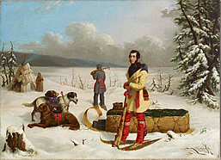 | Irish/Canadian  Painted aboriginal peoples of Canada in the 1800’s  First Canadian painter to earn a living from his artwork
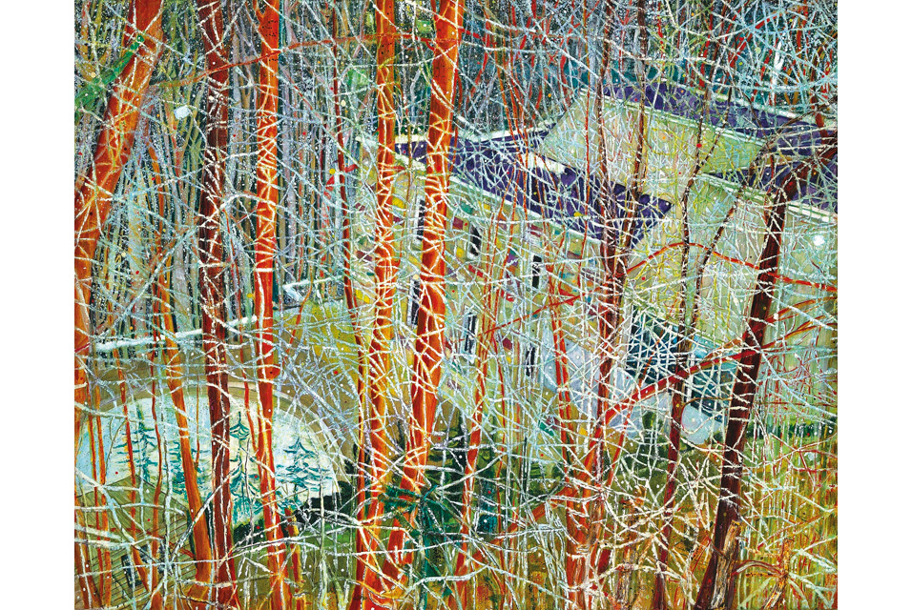 | Born Scotland, lives in Trinidad, lived in Canada for 19 years  His most famous works were painted in Toronto  This painting is Zeidler’s home in Rosedale
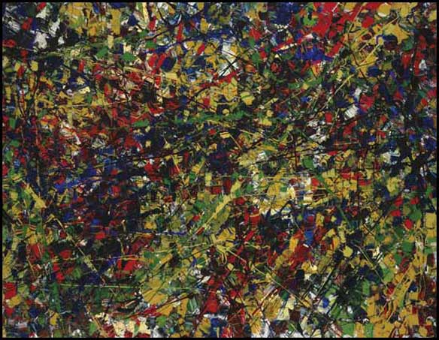 | Studied under Paul Bourduas  Les Automatistes  Thick paint, palette knife, huge canvasses  “When I learn to paint better, I will paint less thickly”
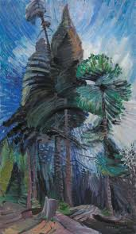 | Exhibited with Group of Seven, but was not included because she was a woman  Inspired by indigenous peoples of Pacific west coast  There is a university in her name in British Columbia  Had a pet monkey
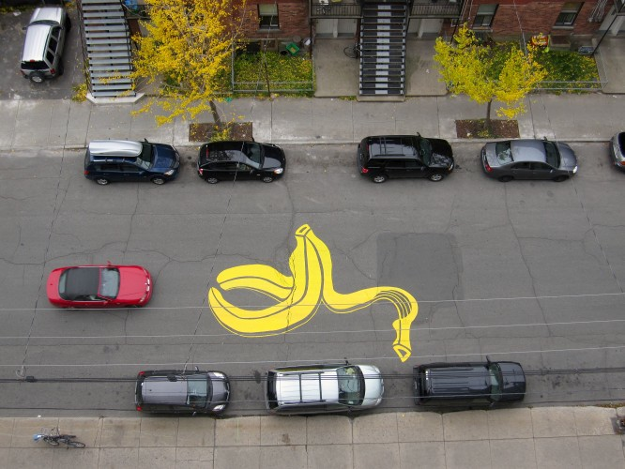 | Arrested many times until he was hired by the City of Montreal as a street artist  Banksy and Andy Goldsworthy are his influences  Has a real name and a pen name
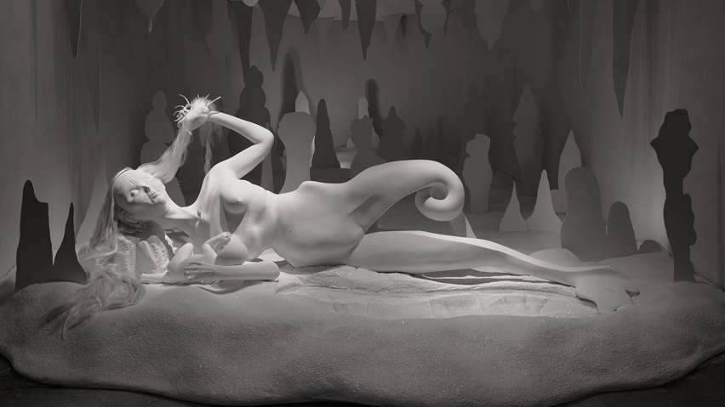 | Creates disturbing porcelain sculptures  Imaginary is narrative (tells a story)  Represented Canada at Venice Biennale 2013

