BLM 2 Teacher Resource

Grade 6, Exemplars of Student Work

Use these exemplars in conjunction with the checklist that you generate with the students. It may also be a good idea to discuss these examples with students so they have a clear idea as to what the expectations are before they begin the project

Box 1
Graphics- Level 4
The graphics are eye catching, neat, and there is clarity of placement. Much thought has gone into the visual impact of the box and use of a focal point.
Text- Level 4
The title of the text is appropriately sized and placed at the top of the box. Secondary information on the front of the box is appropriately sized offering important information to the consumer.
Colour- Level 4+
The student uses high contrast colours which provides a strong visual impact. The sides of the box are printed on lighter purple paper that provides for unity of colour. The cookie on the front of the box is shaded with brown and light orange. The same colour repeats in the smaller circle on the front. This student followed the KISS (keep it super simple) very effectively.
Layout- Level 4
The student has competently used radial balance on the front of the box and allowed ample space for the title to be placed symmetrically above the cookie. The layout is clean, precise and balanced. Overall Mark 4
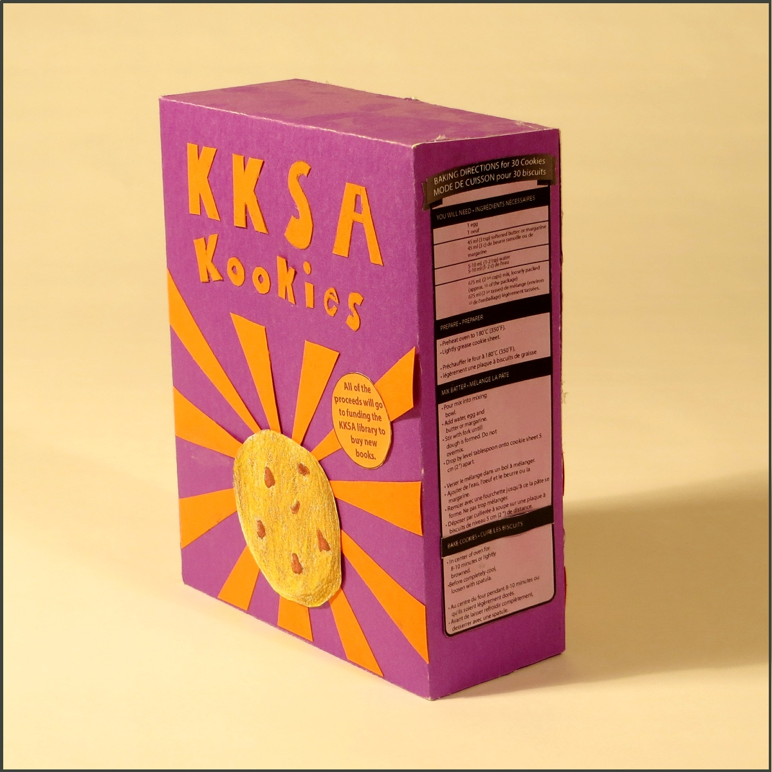

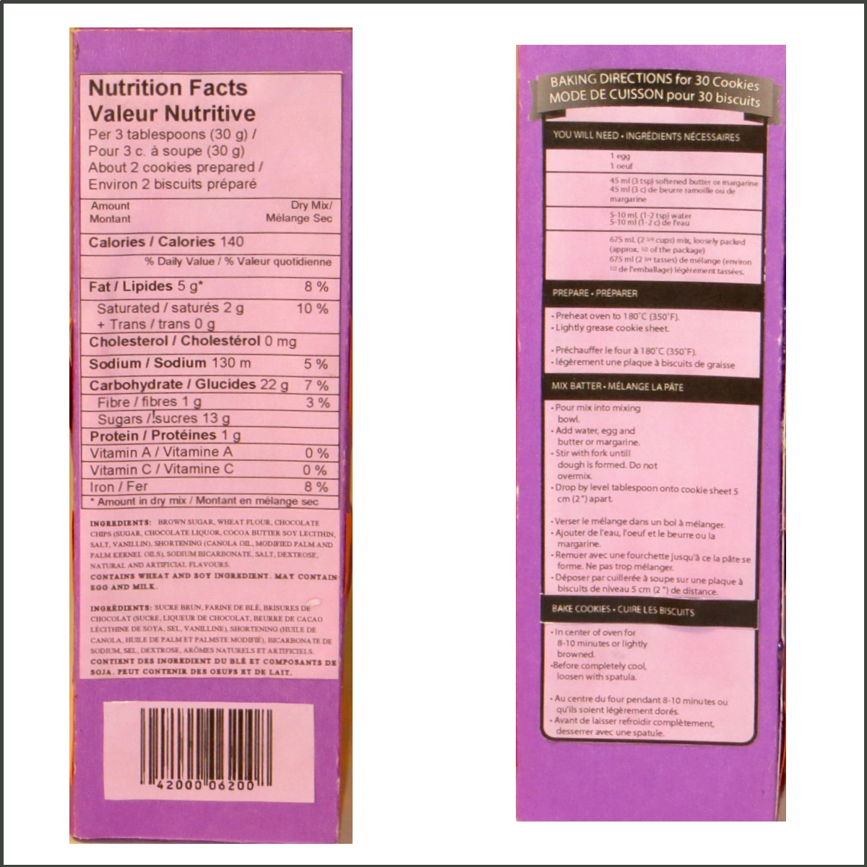
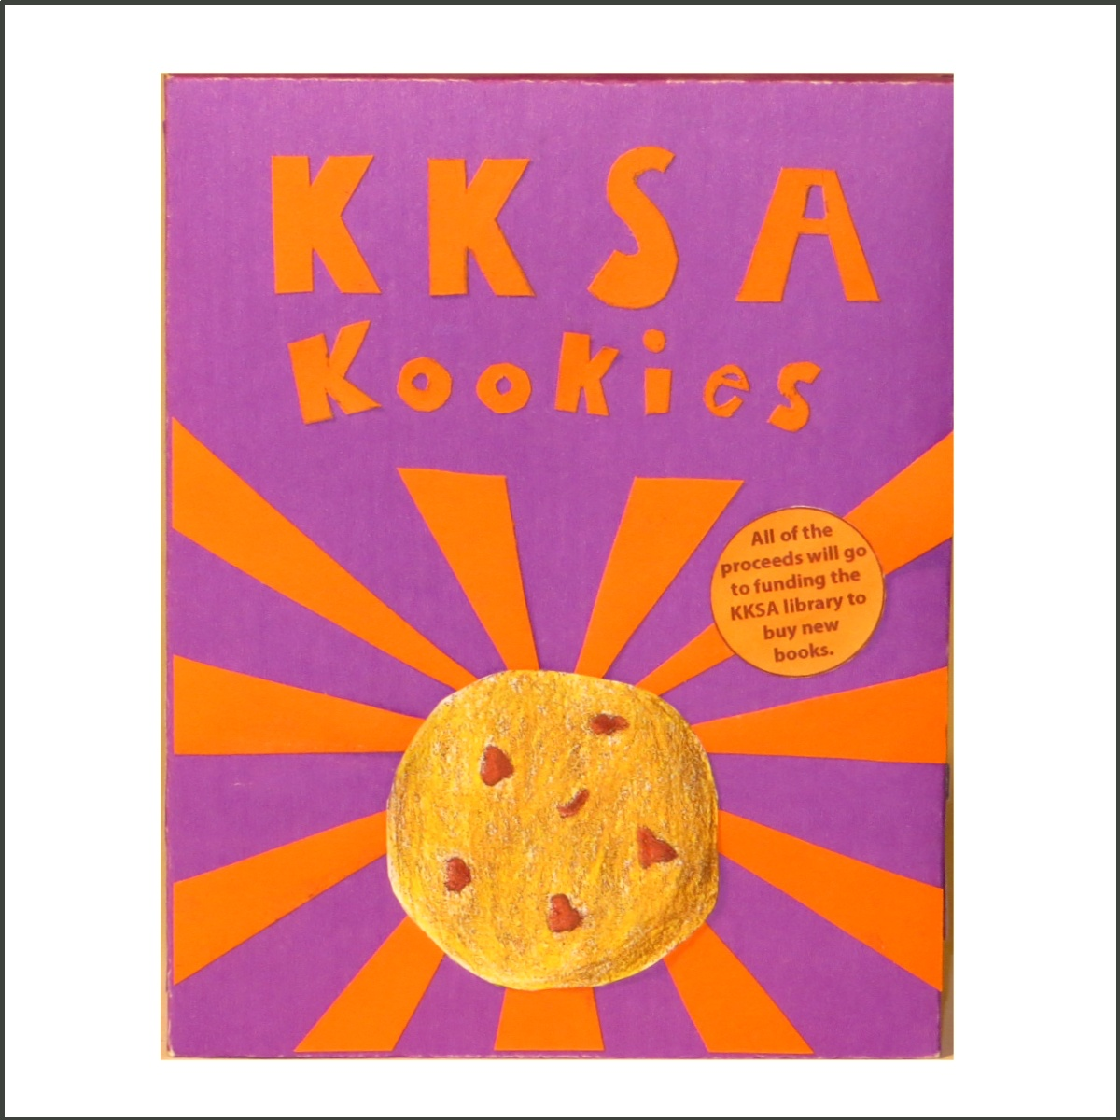
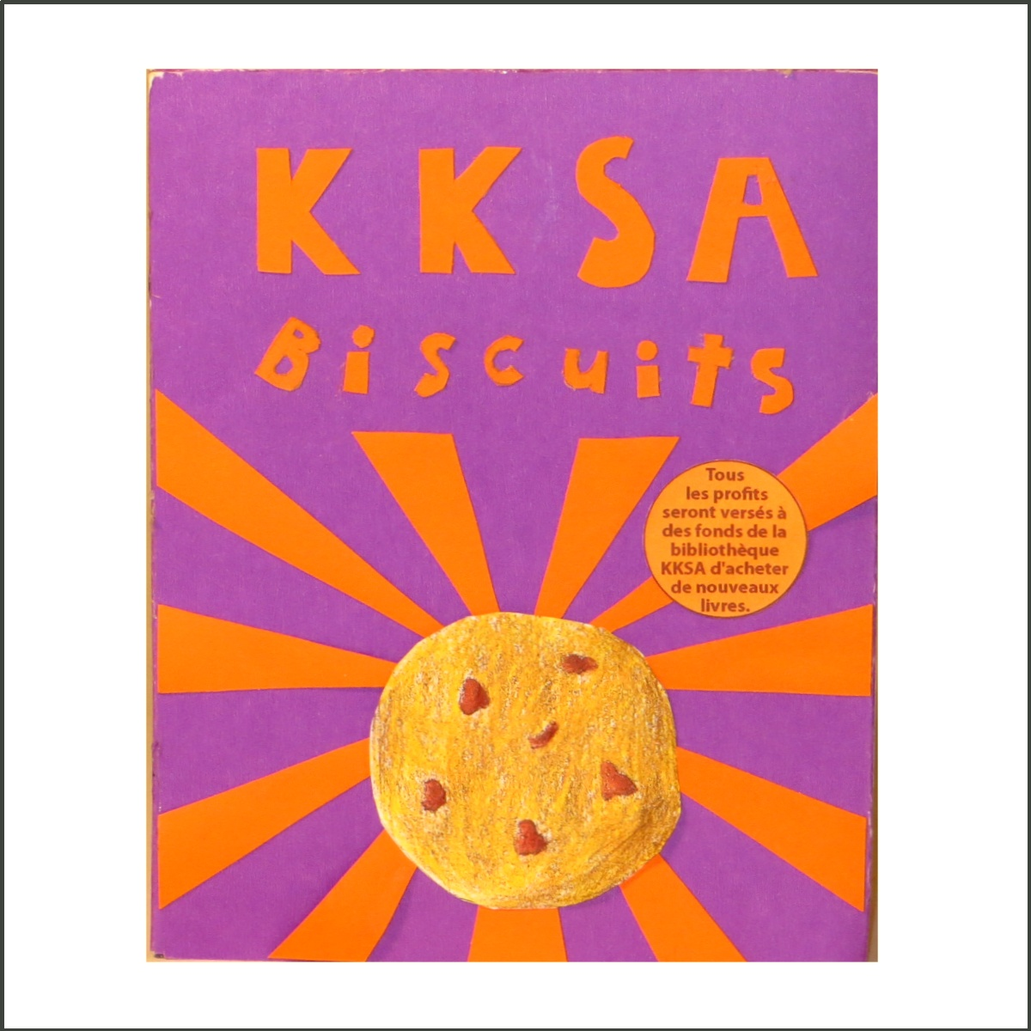
Box 2
Graphics- Level 4 Graphics are eye catching and placed with precision. There is a great deal of detail
Text- Level 3+
Most text is consistently sized, and there are no spelling errors. However, it is difficult to read the baking instructions. And the bubble font should have been solid
Colour- Level 3
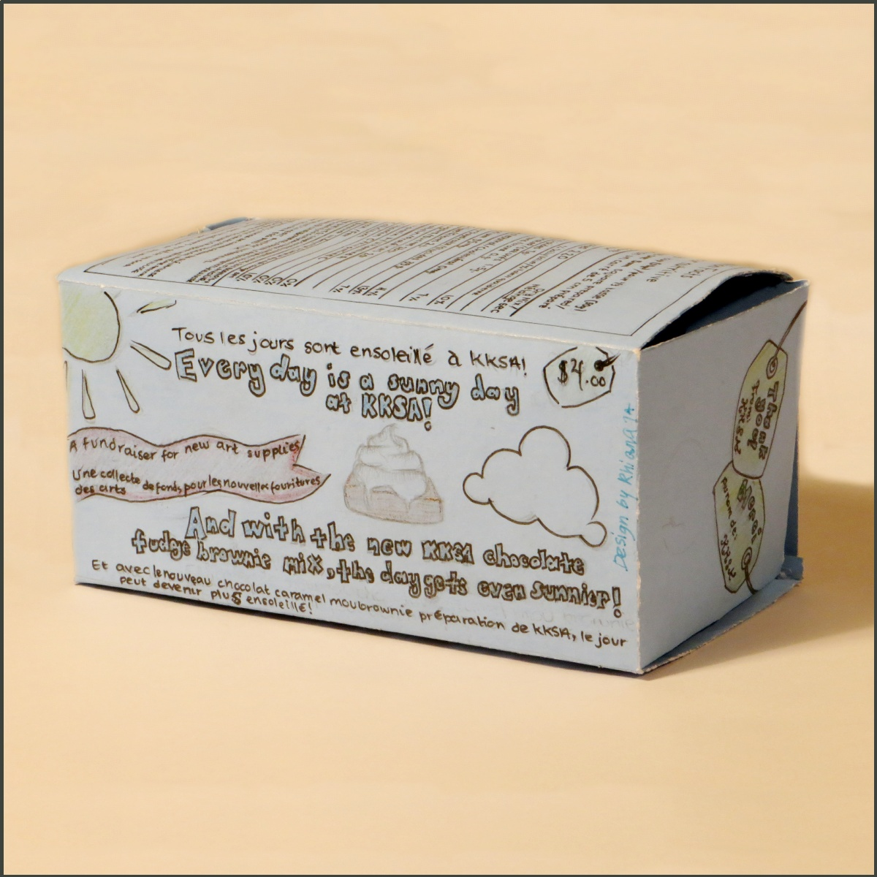
The colours do compliment the overall design and are used consistently, however there isn’t strong contrast of colour or emphasis of colour. The box could have been white offering greater contrast. The chocolate chip cookies have been penciled in and are not coloured.
Layout- Level 4-
The overall layout is balanced, however some precision is lacking. One side of the box is upside down. Overall mark 4-

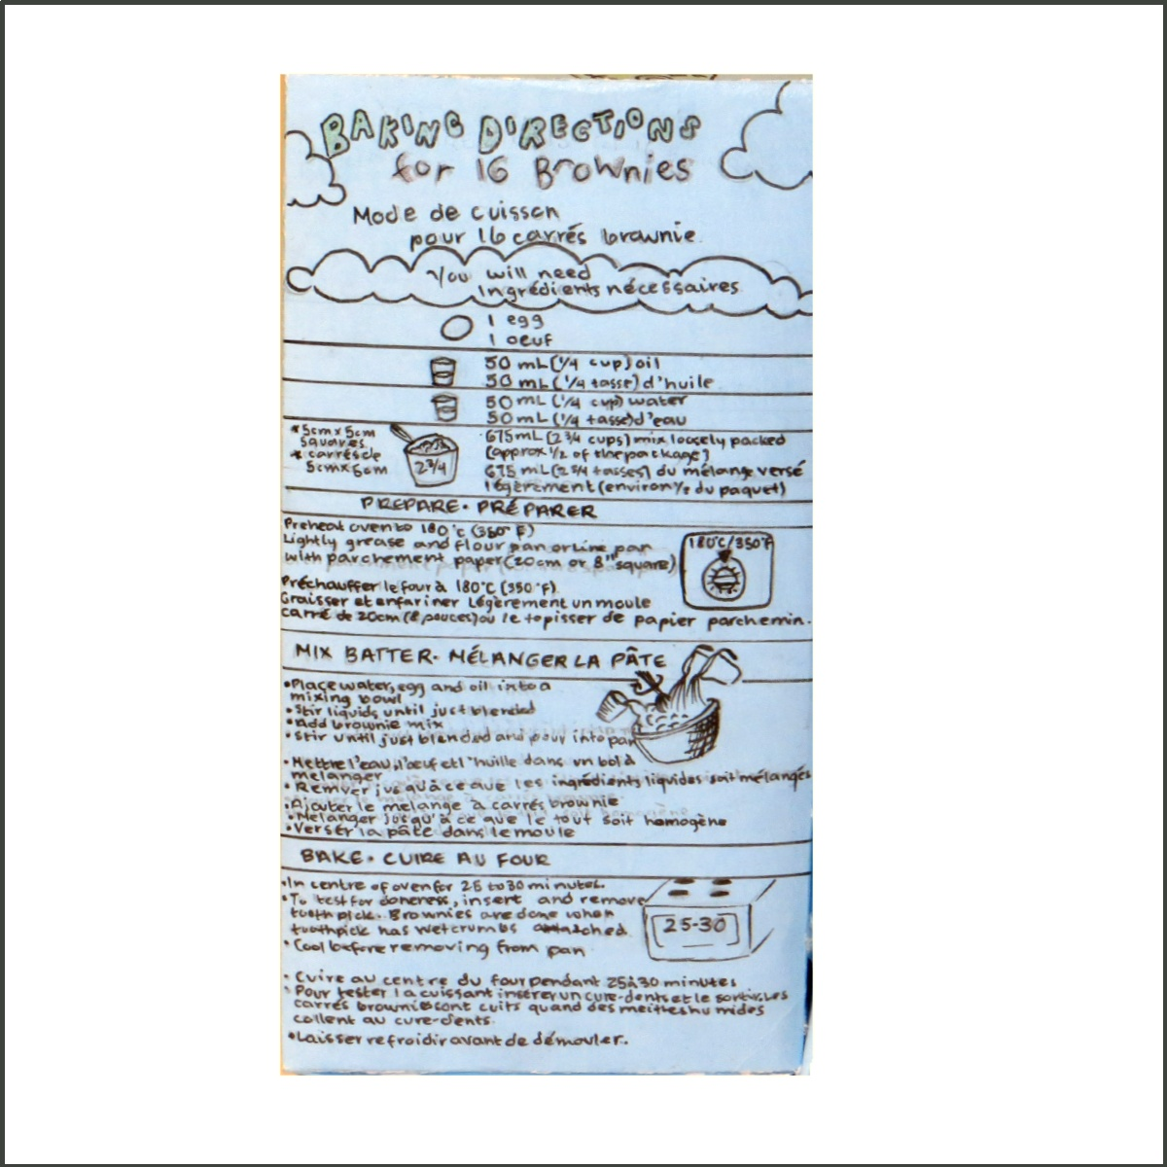
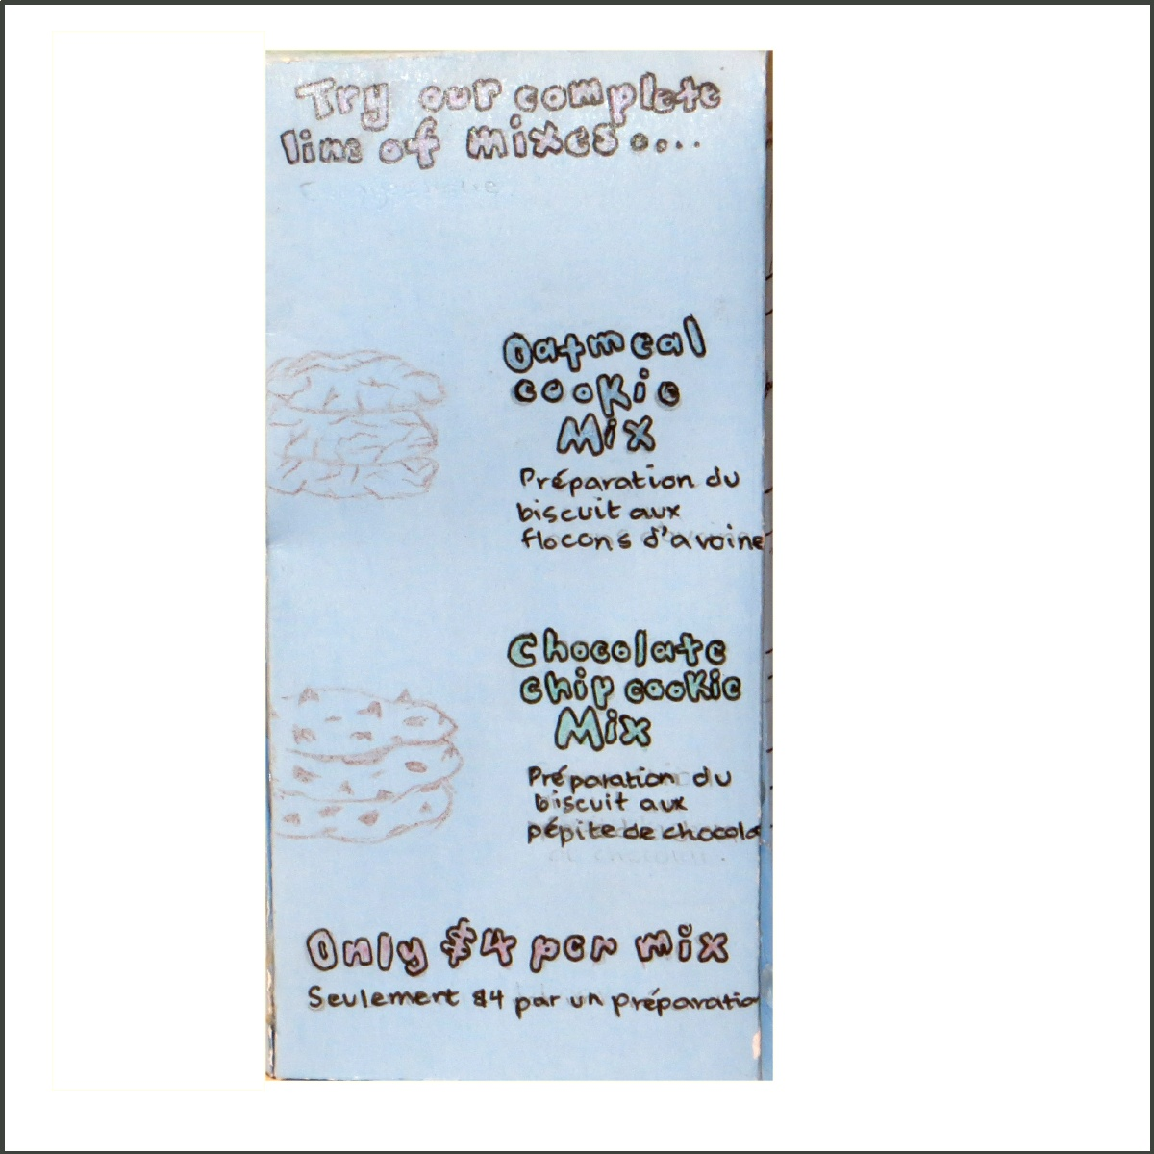
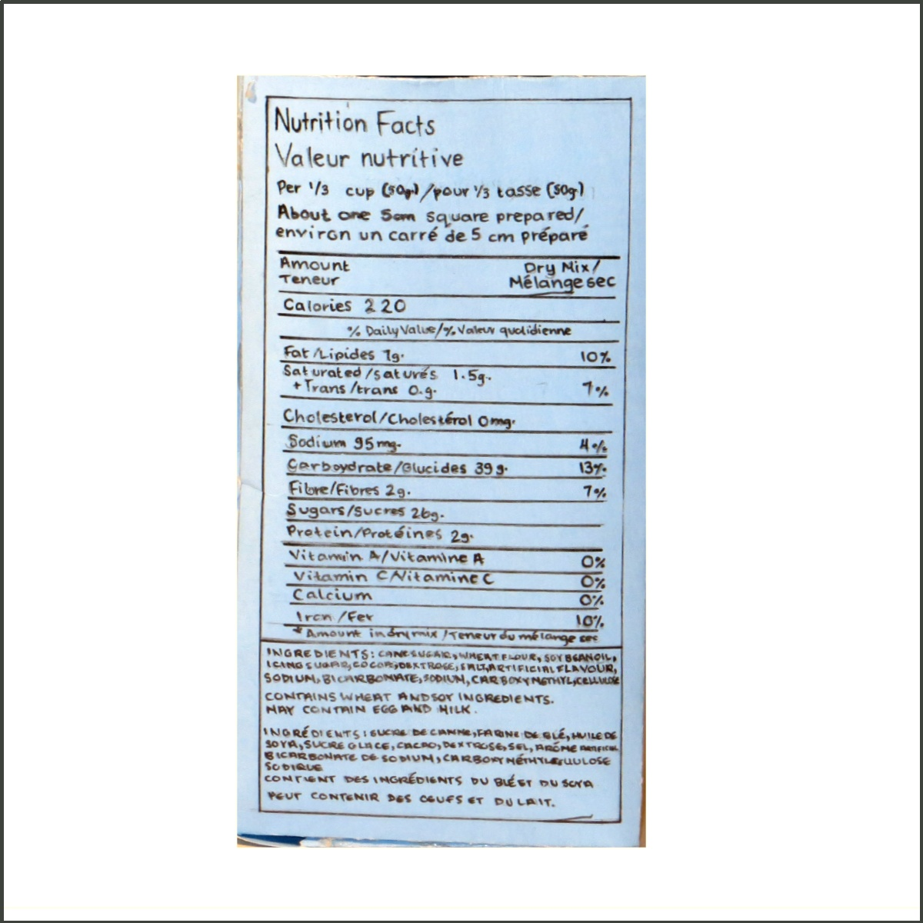
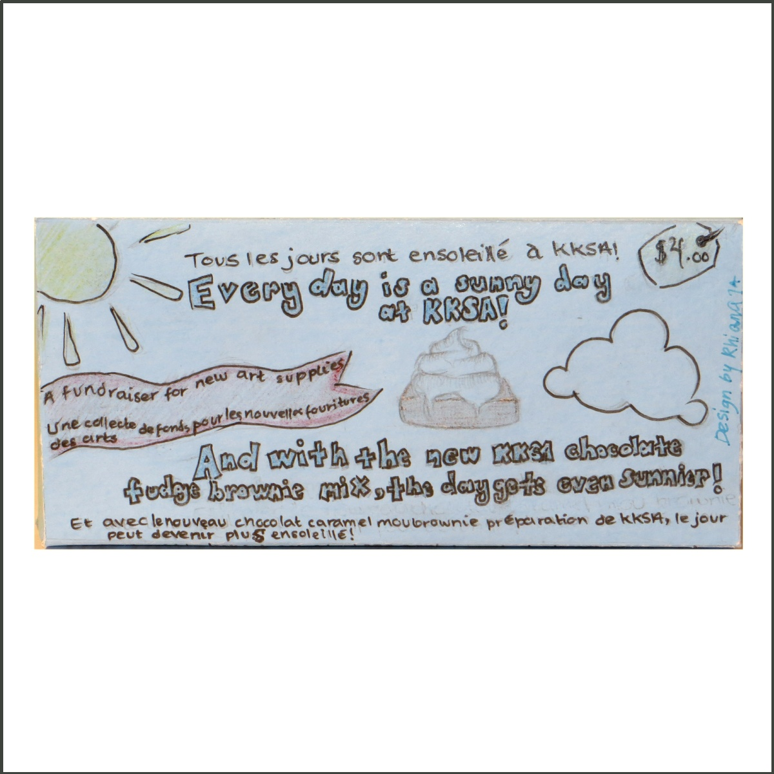
Box 3
Graphics- Level 3+
Graphics are eye catching. The asymmetrical balance works well with the contrast of the shape of the cookie and spoon on the front of the box. The back of the box however isn’t consistent with the front.
Text- Level 3-
The text is well planned spaced and information is appropriately sized on all sides of the box, except for the back. The title, “Chocolate Chip Cookies” on the front could have been larger and more prominent. The text fights with the chocolate chips in the background. The student switches from Serif to Sans Serif font on the front without reason. There is also an inconsistency of font on the side of the box with the logo and plate of cookies. The back of the box is inconsistent and attention to the text appears rushed.
Colour- Level 4-
The Colour is inviting and familiar to many chocolate chip cookie package designs. There is good contrast between the spoon, cookie and background on the front of the box. Red is a good choice of colour for the font. Black on the red ribbon also offers good contrast. Repetition of colour throughout the box offers good unity of design.
Layout- 3+
The overall layout is balanced and not cramped with information. The student lost marks because they excluded design work on the top and the bottom of the box. Overall Mark 3+
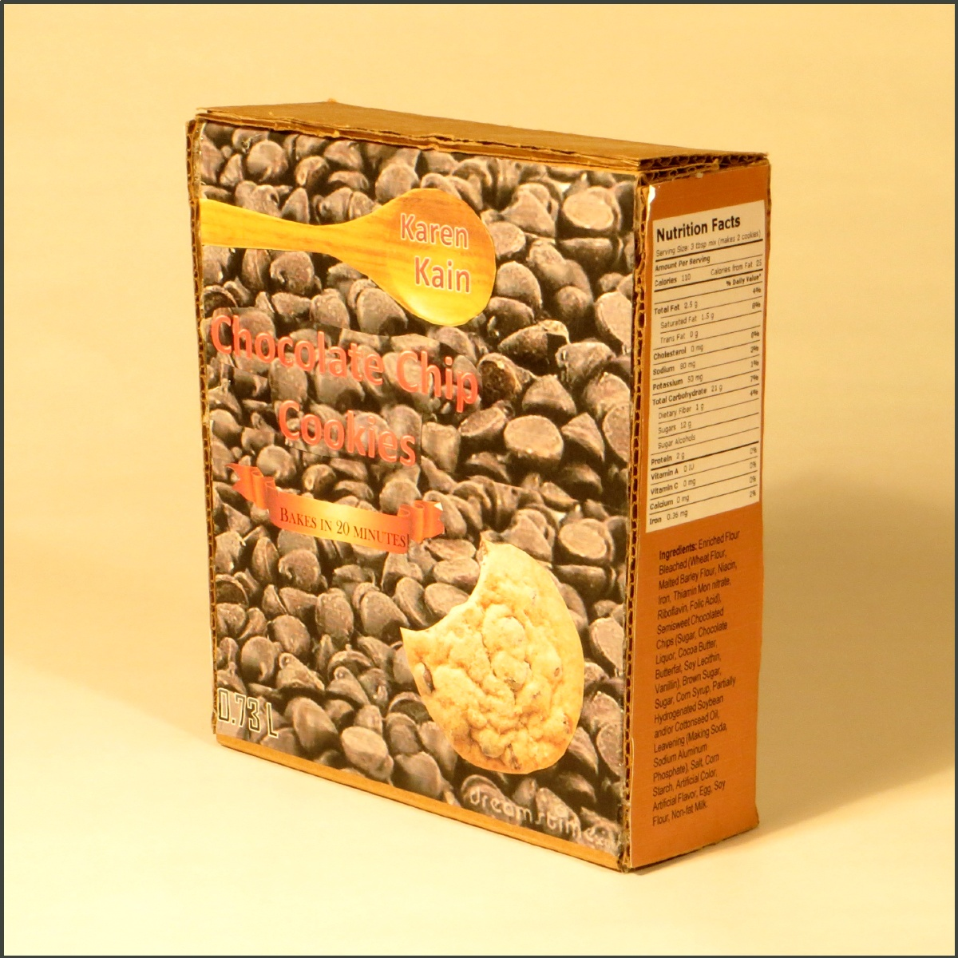

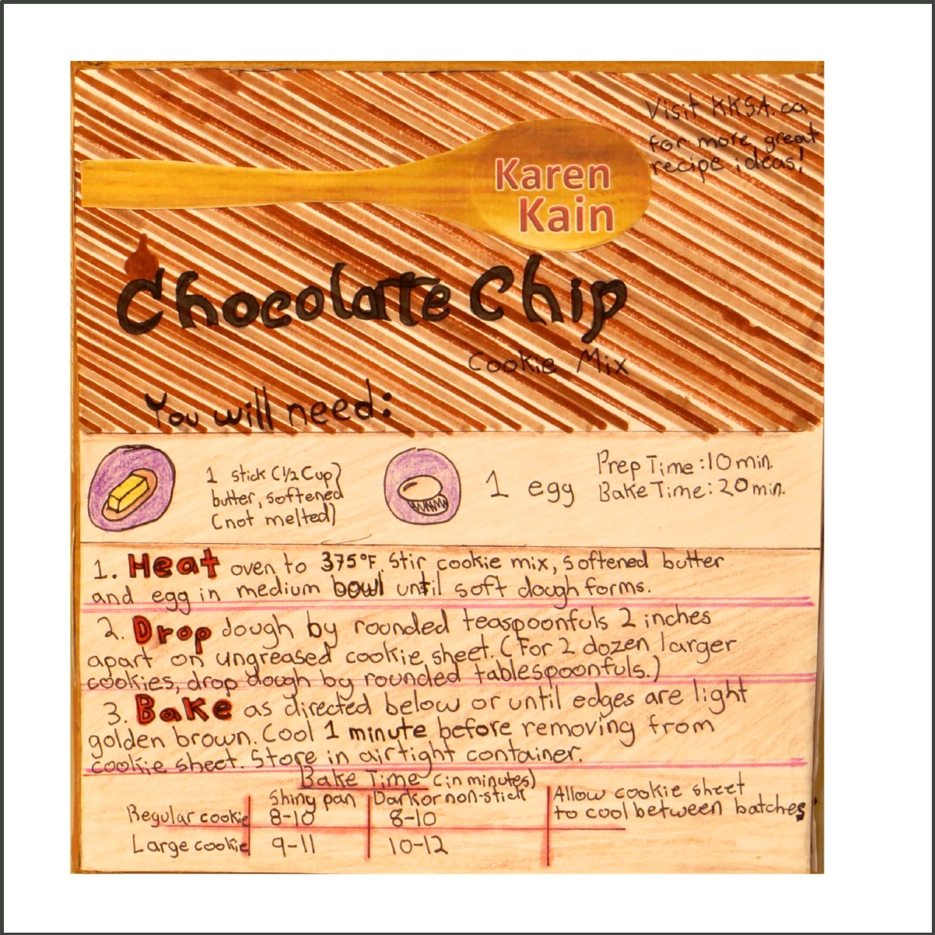
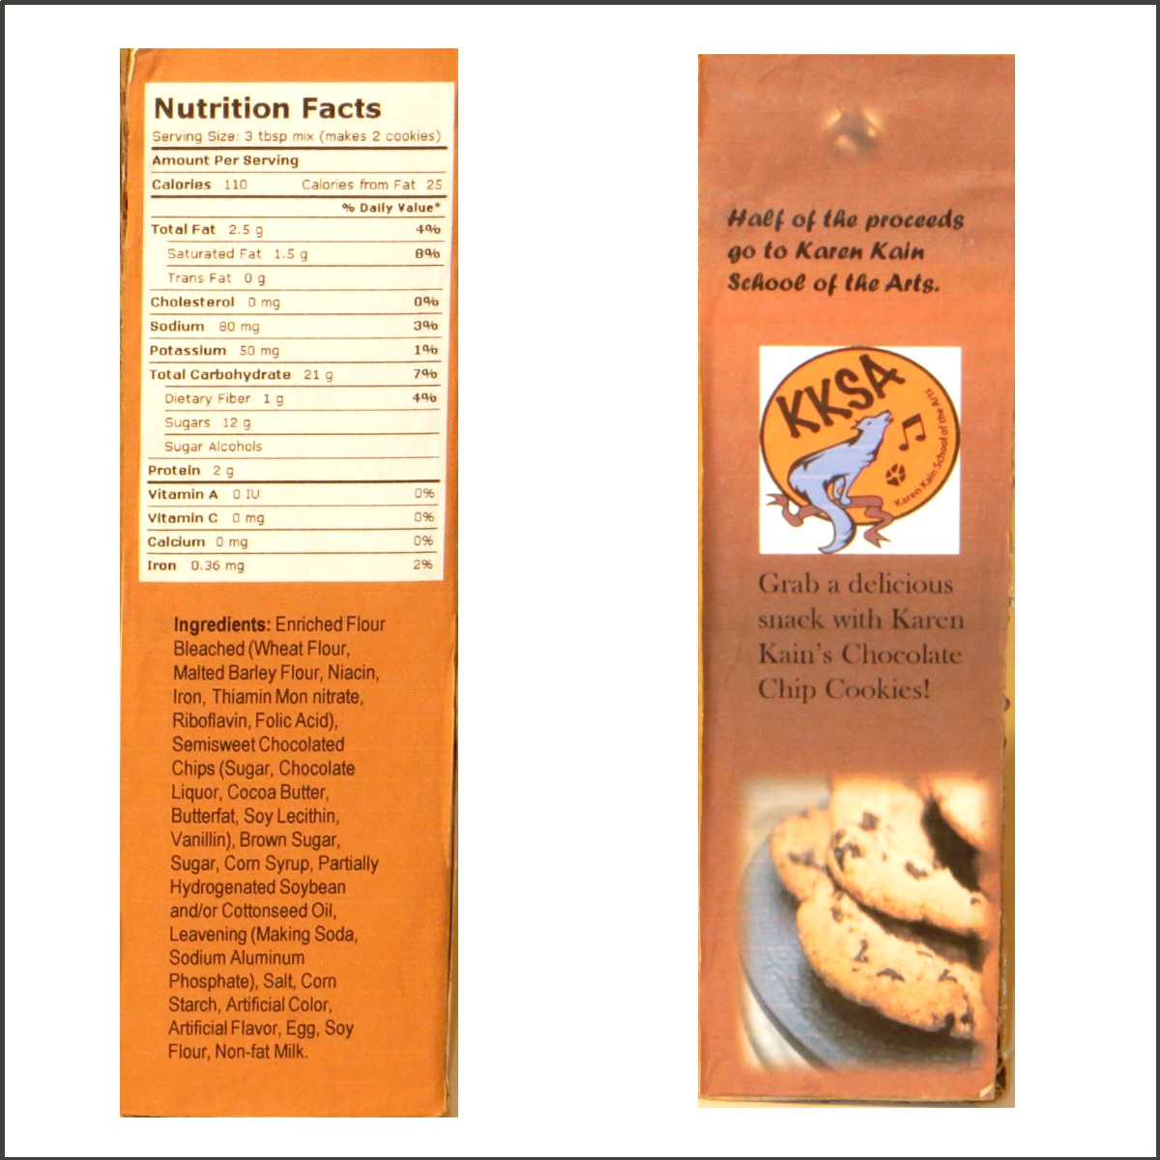
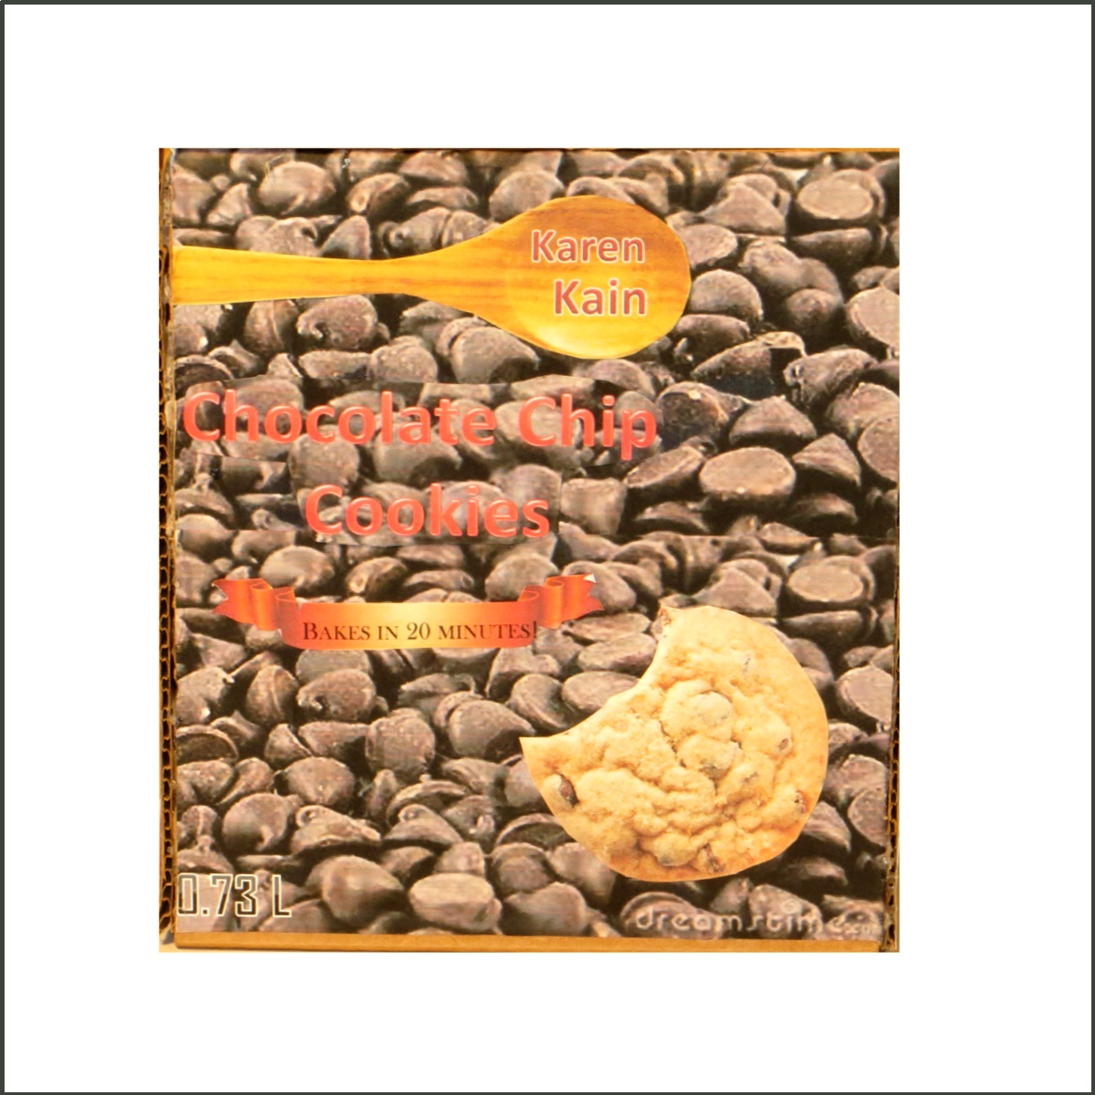
Box 4
Graphics- Level 3
are appropriately placed on the front of the box, however they aren’t neat. The rest of the box is lacking in graphics and they aren’t fully executed. The back of the box has a book which represents the library. The book is small and isn’t fully coloured.
Text- Level 2+
The text is not uniform and on occasion is written on an angle. Attention to text isn’t evident and appears rushed. The font size doesn’t appear to be a consideration. Although there are no errors in spelling, the text on the back of the box appears to be a long run on sentence. Capitols are used inappropriately.
Colour Level 2+
The student uses the school colours on the front of the box. This offers high impact as they are complimentary colours. They don’t however say anything about the contents of the box. Without the word cookie, one would never know it was a package for chocolate chip cookies. There is little thought to colour in the rest of the box and it appears to be incomplete.
Layout - Level 2
The overall layout appears to be somewhat disorganized. The world “crunch” fights with the school logo as the focal point. The coyote in the logo is swallowed by the blue background of the box, and the word,“cookie” is too small. It appears that little consideration went into the sides and back of the box.
Overall Mark 2+
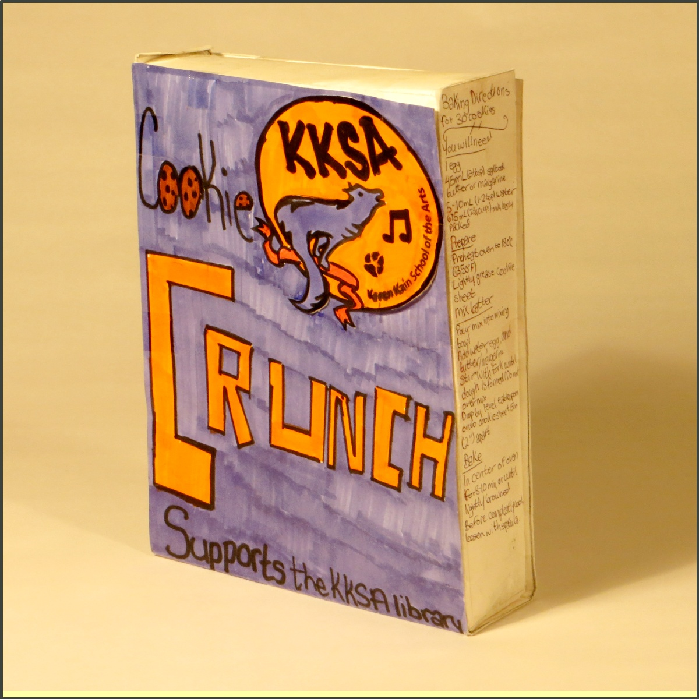

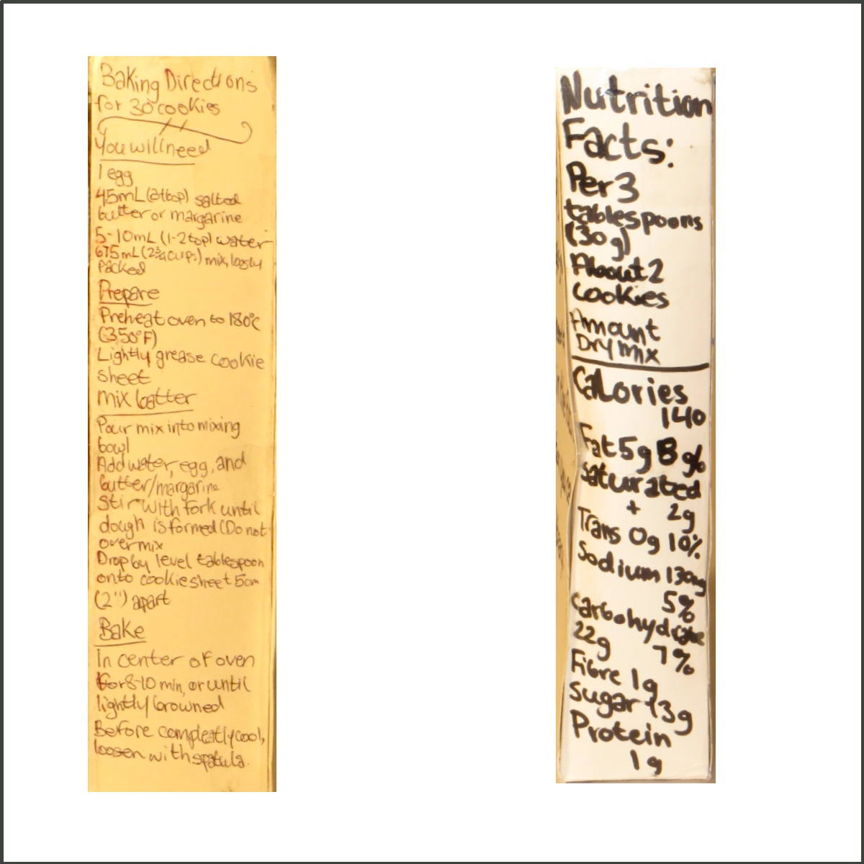
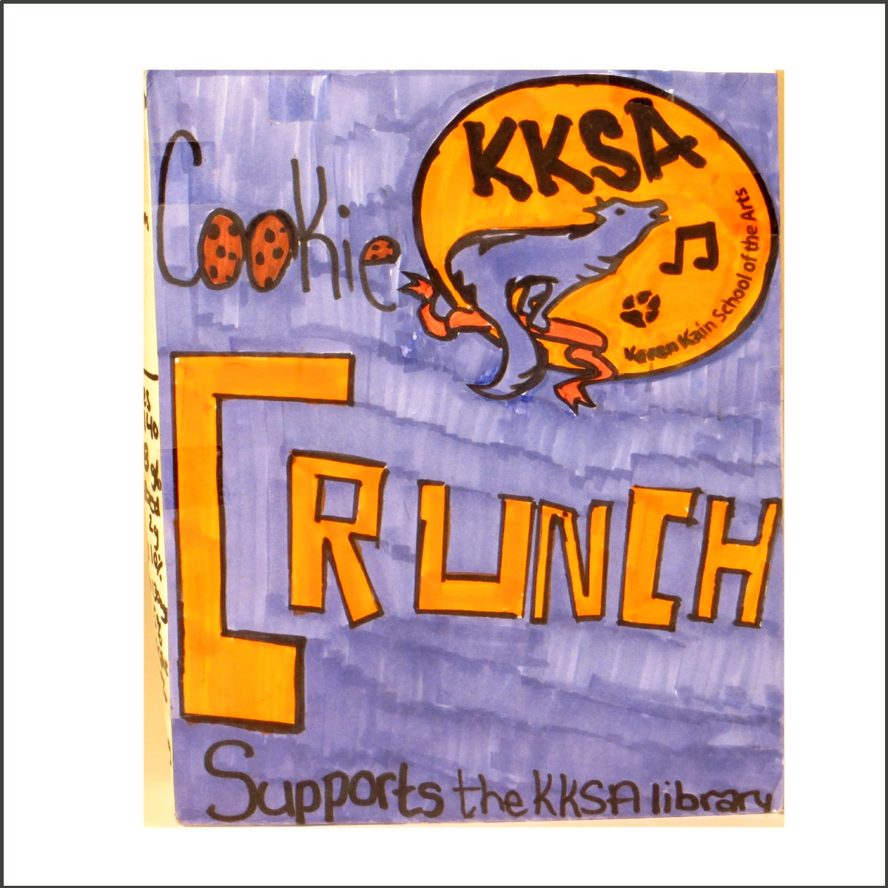
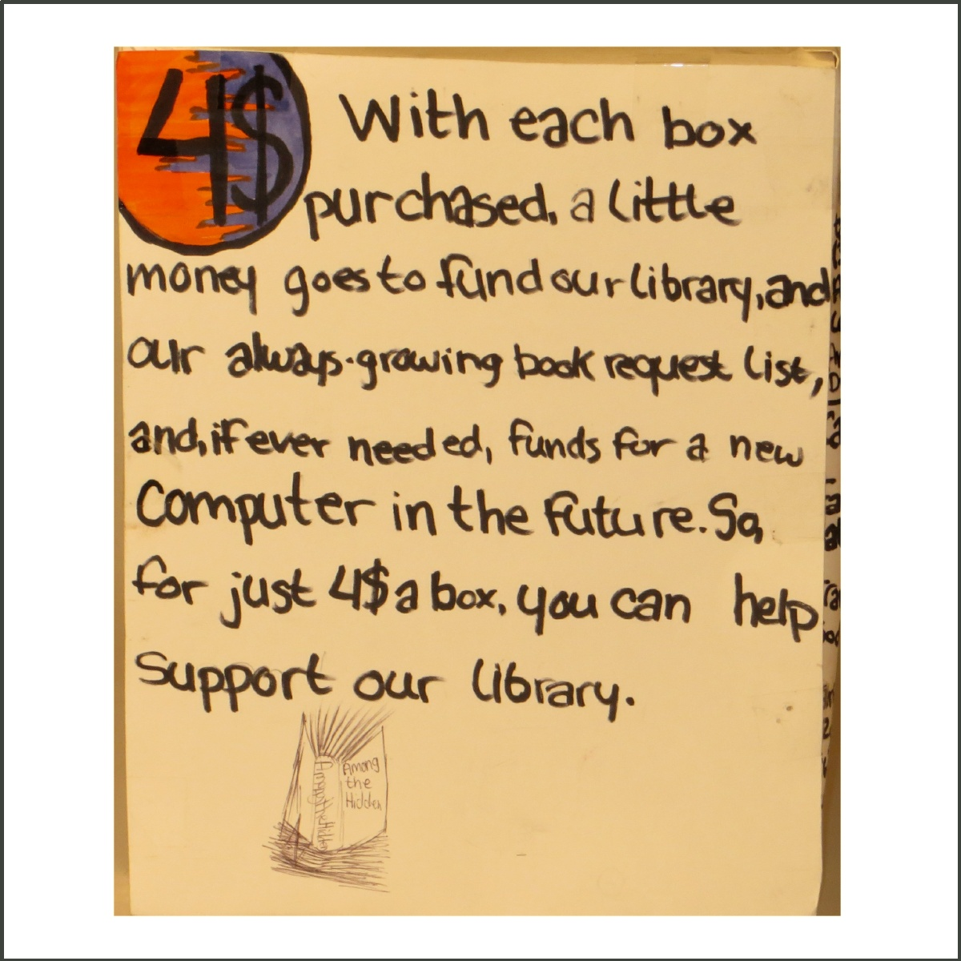
Box 5
Graphics- Level 1
Student has circled a cube that hangs in space. It is assumed that the circle is supposed to be a plate, and that the cube is supposed to be a brownie. The graphics are unclear and not fully executed.
Text- Level 2
The secondary information is not uniform in size. There is far too much variety of size in the font. The bubble letter font is also difficult to read. There are several errors in spelling and grammar.
Colour- Level 1
Aside from the orange colour of the box, the student hasn’t considered colour. The font is a muddy brown and the brownie on the front looks unappetizing. Not enough colour is used and the colour that is used isn’t well planned out.
Layout- Level 2
The layout is somewhat disorganized and little attention went into any particular kind of balance. The asymmetrical design on the front of the box is less successful than the back of the box. The back uses the rule of thirds to divide the page.
Overall Mark 2-



