BLM 2 Teacher Resource
Grade 8, Guess the Sale Price ANSWERS
ARTWORK | HINTS | Price
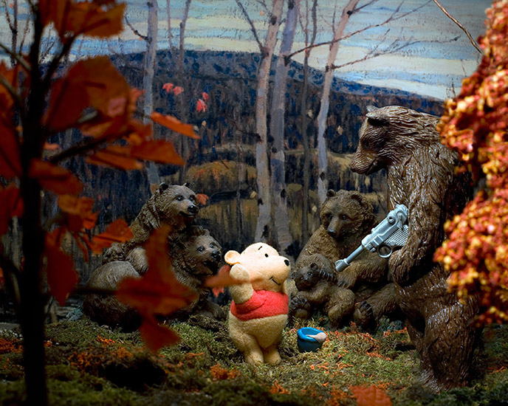 | Diana Thorneycroft  Series: Group of Seven Awkward Moments (Maples and Birches with Winnie and the Pooh), 2008  - One of Top 10 Exhibitions of 2008  - Winnipeg artist, photographer  - Imaginary scenes of dolls and toys with art backgrounds | $1,000-5,000  2013
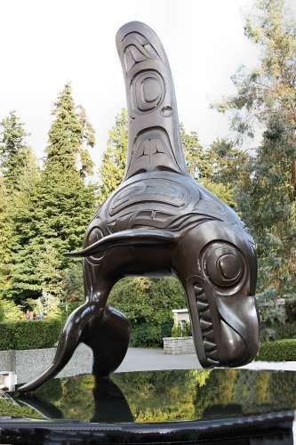 | Bill Reid  The Killer Whale (bronze sculpture), 1984  - BC artist  - Natural & mythological worlds  - Indigenous artist | $700,000  2010
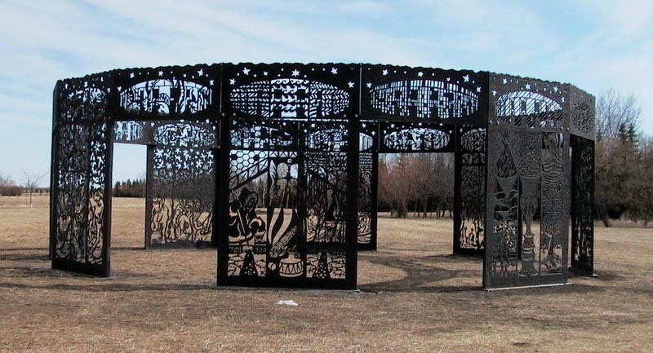 | Joe Fafard  Mind’s Garden (metal sculpture installation), 1999  - From Saskatchewan  - Sculptures on Canadian postage stamps  - His bronze cows are at the TD Centre in Toronto | $800,000  1999
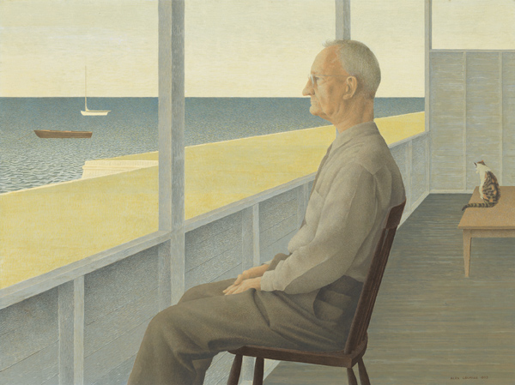 | Alex Colville  Man on Verandah, 1953  - Died in 2013  - The sale of this painting set a record for highest for a LIVING Photo-realist Canadian artist from Nova Scotia  - Designed penny, nickel & dime for Canadian mint | $1.29m  2010
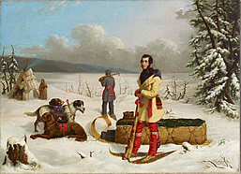 | Paul Kane  Scene in the Northwest: Portrait of John Henry Lefroy, 1845-46  - Irish/Canadian  - Painted aboriginal peoples of Canada in the 1800s  - 1st Canadian painter to earn a living from his artwork alone | $5,062,500  2002
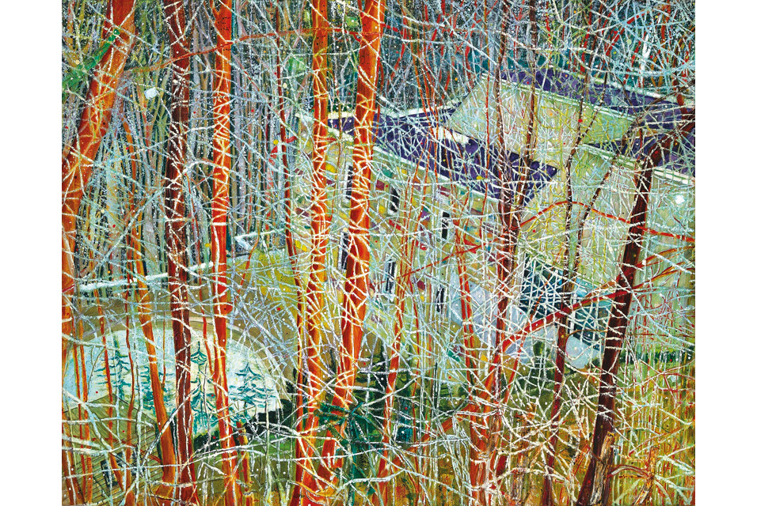 | Peter Doig  The Architects Home in the Ravine, 1991  - Born in Scotland, lives in Trinidad, lived in Canada for 19 years  - His most famous works were painted in Toronto  - This painting is Zeidler’s home in Rosedale | $12m  2013  (not really Canadian)
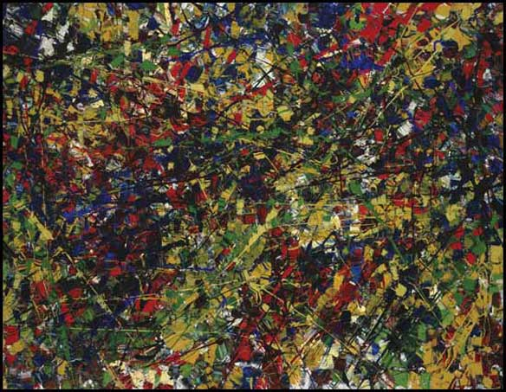 | Jean Paul Riopelle  Jouet, 1953  - Studied under Paul Bourduas  - Les Automatistes  - Thick paint, palette knife, huge canvasses  - “When I learn to paint better, I will paint less thickly” | $1.17m  2009
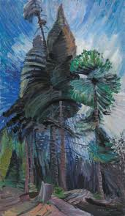 | Emily Carr  Wind in the Tree Tops,  1936-39  - Exhibited with Group of Seven, but was not included because she was a woman  - Inspired by indigenous peoples of Pacific west coast  - There is a university in her name in BC | $2.16 m  2009
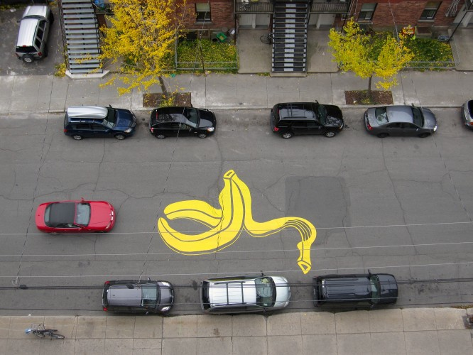 | Peter Gibson aka Roadsworth  16 x 20 print, 2012  - Arrested many times until he was hired by the City of Montreal as a street artist  - You can commission bigger works and murals for much more money  - Banksy and Andy Goldsworthy are his influences | $100
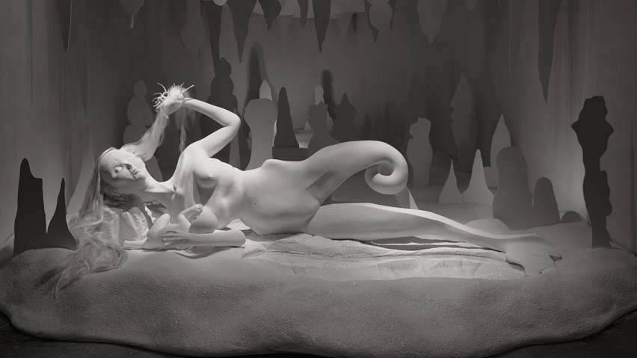 | Shary Boyle  Music for Silence, Porcelain sculpture/installation, 2013  - Disturbing porcelain sculptures  - Imaginary narratives  - Represented Canada at Venice Biennale 2013 | Cost to produce  $1.5m  2013

