BLM 4 Teacher Resource
Grade 7, I shop therefore I am Artist Examples
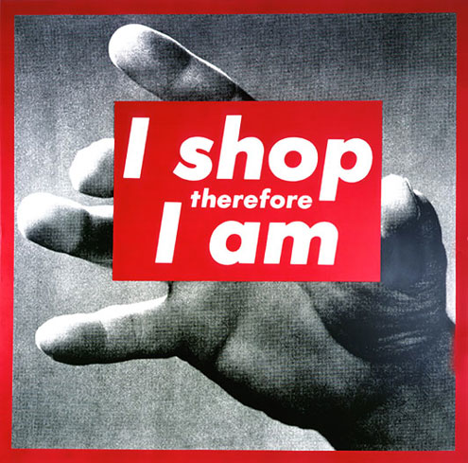 | Barbara Kruger (American, 1945)  Untitled (I shop therefore I am)  photographic silkscreen/vinyl, 1987  Known for her work of black-and-white photographs with white on red Helvetica declarative captions; uses mass communication and advertising to explore gender, identity and consumerism
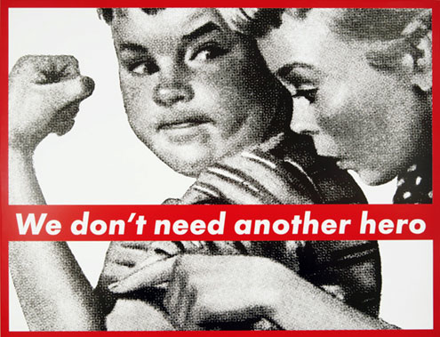 | Barbara Kruger (American, 1945)  Untitled (We don’t need another hero)  photographic silkscreen/vinyl, 1987.  Juxtaposition and appropriation of images and text “mashes up” meanings to create new ones.
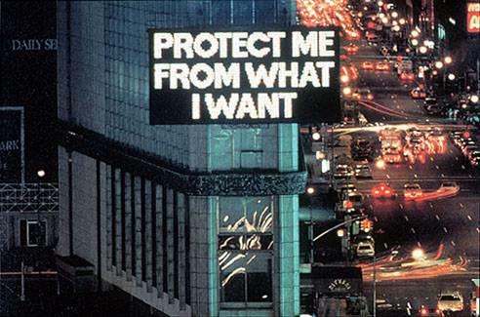 | Jenny Holzer (American, 1950)  Times Square Spectro Billboard, NYC.  Jenny Holzer's Truisms are "truths" that lie at the boundary of truth and our perception of truths in the post-modern landscape. Holzer inserts her truisms into public spaces, on T-shirts, and electronic billboards placed in museums and galleries.
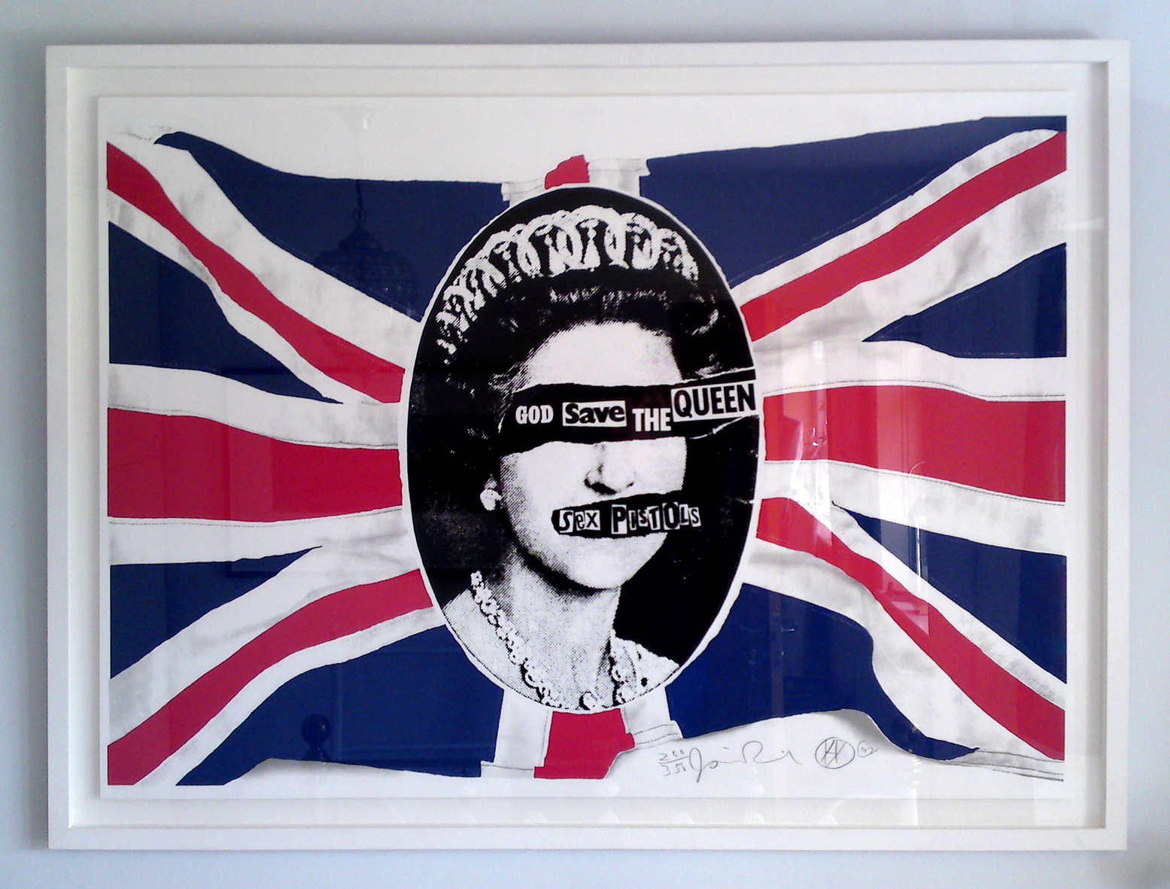 | Jamie Reid (UK, 1947)  God Save the Queen  Silkscreen, 1977.  Artist and anarchist; famous for establishing the DIY style of the 70’s Punk Movement; designer of the “Sex Pistols” album covers.
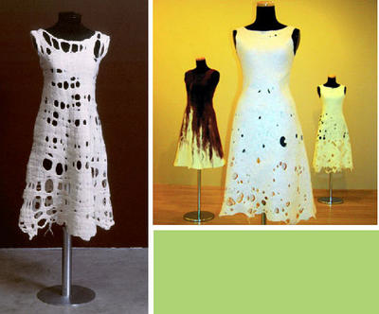 | Andrea Zittell (US, 1965)  Mixes issues of architecture, design, fashion and ergonomics; creates installations and objects that challenge traditional uses of tools, garments and living spaces; makes unique items out of recycled garments; anti “sweatshops.”
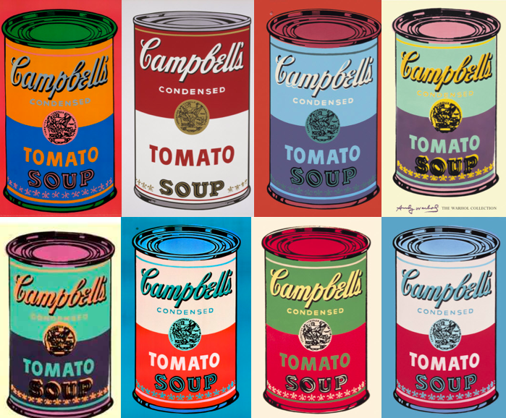 | Andy Warhol (American, 1928-1987)  8 Campbell Soup Cans  Silkscreen on paper, 1968.  Known for “pop art”; explored relationship between art and celebrity culture and advertisement in the 1960s
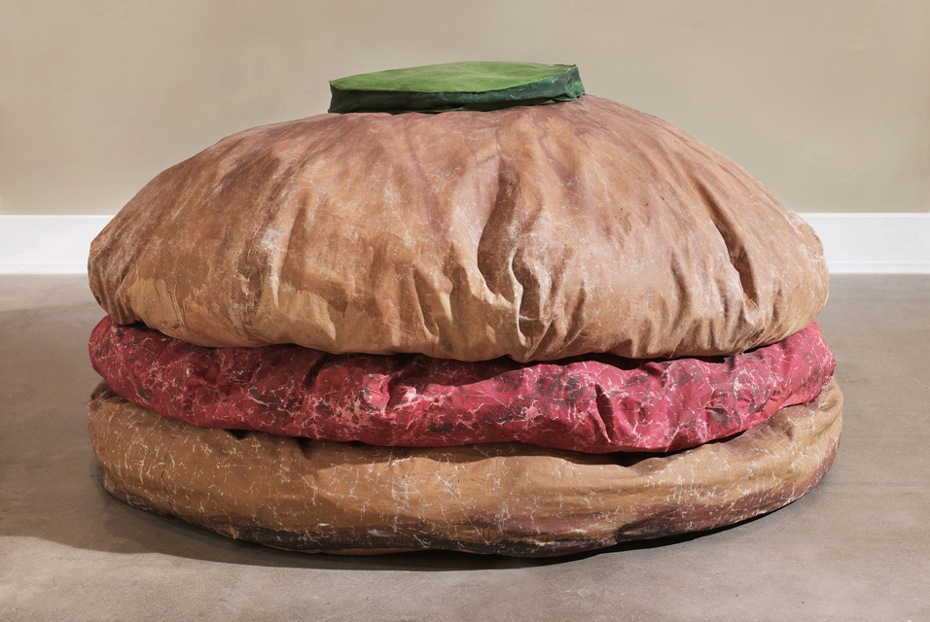 | Claes Oldenburg (Sweden/US, b.1924)  Hamburger  1962.  Sculptor (usually very large replicas of everyday objects)
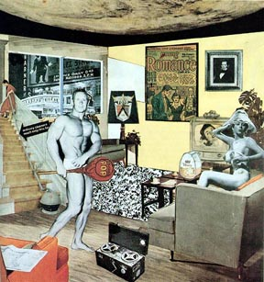 | Richard Hamilton (UK, 1922-2011)  Just what it is that makes today’s home so different, so appealing?  Collage, 1956.  Earliest pop art; collages incorporating ads from mass media
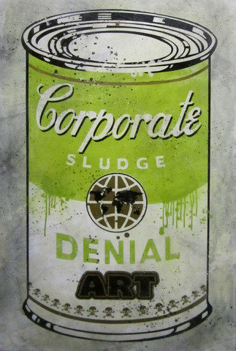 | Denial (Canadian, b. 1980’s)  Corporate Sludge  Graffiti and mixed-media artist, pokes fun at modern advertising, politics and media messages that society is often “in denial” about. In this image he plays off Warhol’s iconic image of Campbell’s Soup can.
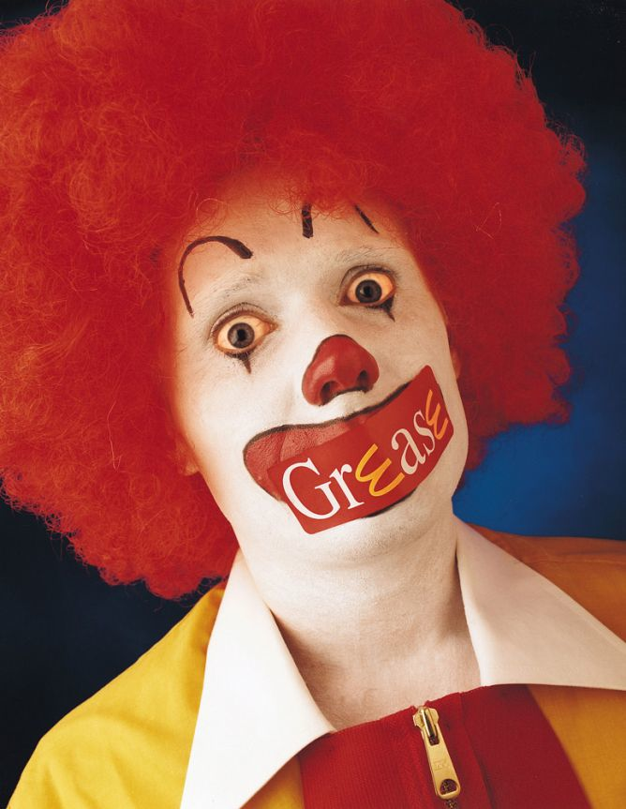 | Adbusters  McGrease  Canadian based, not-for-profit, anti-consumerist, pro-environment organization founded in 1989 by Kalle Lasn and Bill Schmalz in Vancouver; publishes the reader-supported “Adbusters” activist magazine devoted to challenging consumerism; they also launch numerous international campaigns including “Buy Nothing Day”
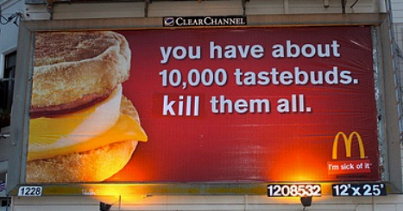 | Billboard Liberation Front  Untitled  Altered advertisements, 1970’s to present  Practices culture jamming by altering billboards by changing key words to radically alter the message, often to an anti-corporate message. Started in San Francisco in 1977.
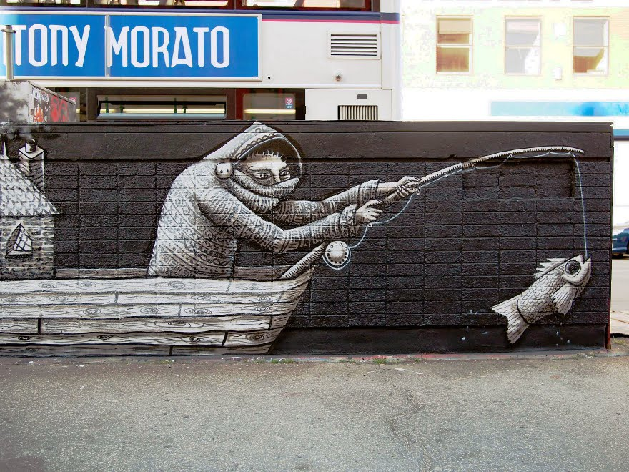 | Phlegm (UK, unknown)  Street artist, cartoonist, illustrator; paintings become part of the city’s architecture; often makes commentary about environmental issues
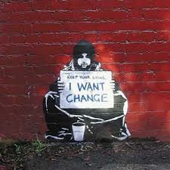 | Banksy (UK, unknown identity)  Untitled  Graffiti artist whose stencil graffiti works often have dark humour with social justice themes; began in Bristol, England and has travelled throughout the world; his artworks have gone from street to gallery and can fetch over $200,000Cdn.
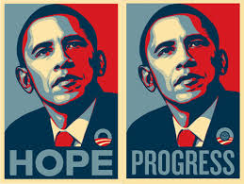 | Shepard Fairey (US, 1970)  Hope  Silkscreen, 2008  Street artist, graphic designer activist also known for his “Obey” (Andre the Giant) sticker campaign; often criticized for appropriation, he claims “Fair Use” which is determined by how much a new work changes an older one and says his works do not infringe on copyright
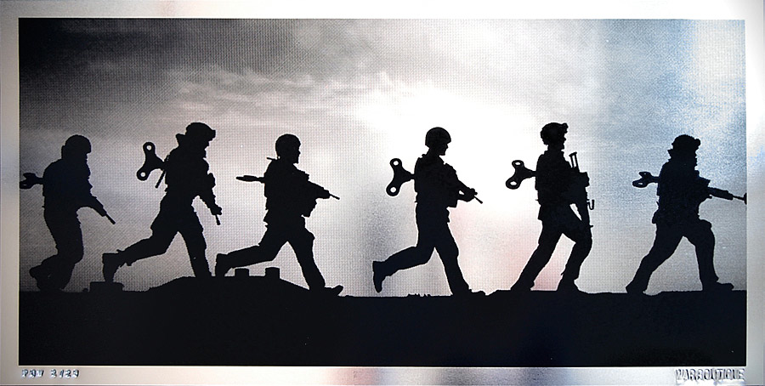 | War Boutique (London, UK)  Untitled  Street artists recycle ballistic military materials in reaction to the Iraq war as a symbolic gesture of peace; attempt to record the events that aren’t covered in the news and document them as pieces of social commentary
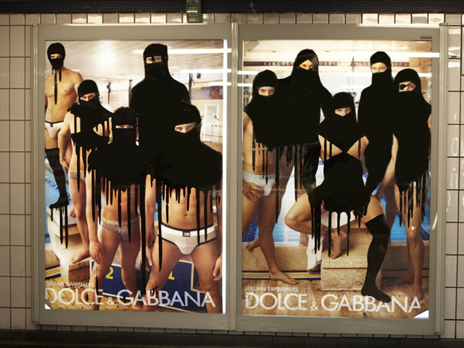 | Princess Hijab (Paris, France, b. 1988)  Anonymous female street artist veiling the main characters of subway advertisements using black paint. This movement is also called “Hijabism”, primarily a protest against the French government’s efforts to ban the burqua in public.
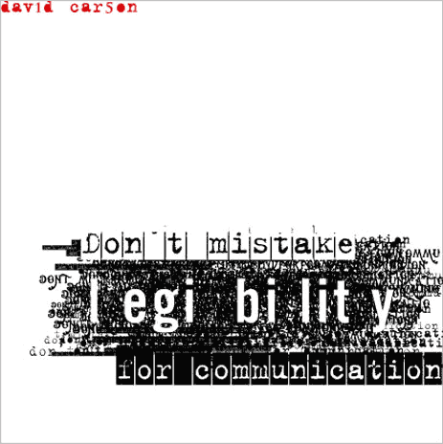 | David Carson (US, b. 1954)  Don’t mistake legibility for communication  Graphic designer best known for innovative magazine design and experimental typography; text becomes part of the message itself, uses text as an expressive medium (grunge style); inspired by Jamie Reid and DIY punk movement
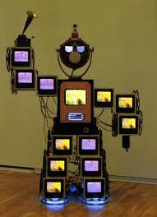 | Nam June Paik (Korea, 1932, died US 2006)  Founder of video art; commentary on media (made robots from TV’s); mixed media
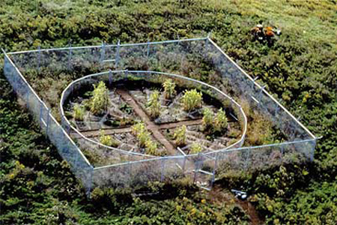 | Mel Chin (US, 1951)  Revival Field  “Remediation” of land ruined by human disasters (oil spills, nuclear meltdowns, sewage runoff etc.); aim to cure polluted areas; eco-artist, conceptual visual artist motivated by political, cultural and social circumstances; site-specific installations that demand audience participation
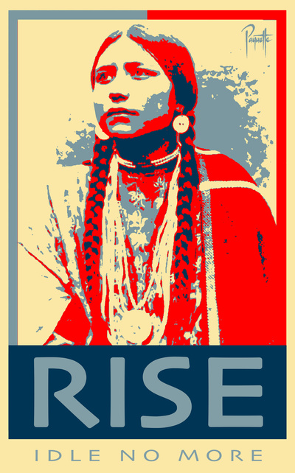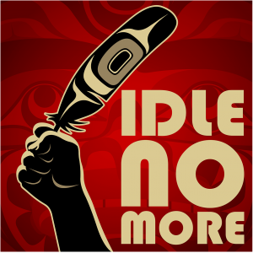 | Aaron Paquette  Rise, 2013.  Appropriation of Shepard Fairey’s “Hope”  Andy Everson  Idle No More, 2013.  Images and official “logo” of the movement  Sometimes artwork is part of a specific political movement, as in these indigenous works for Idle No More.

Historical Context:
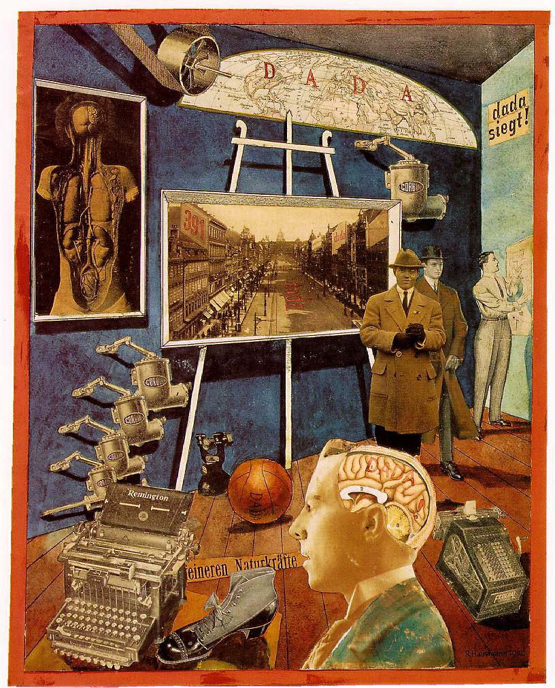 | (Dada; Surrealism)  Raoul Hausmann (German 1886-1971); Dada (an anti-art movement); early photographic collage; profound influence on European avant-garde artists post WWI
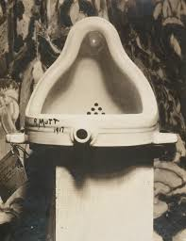 | Marcel Duchamp (French/US 1887-1968)  This scandalous work was a porcelain urinal which was signed “R. Mutt” and titled Fountain. It was typical of Dada’s anti-art statements.
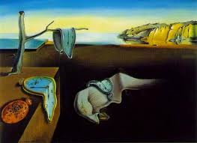 | Salvador Dali (Spain 1904-1989)  The Persistence of Memory, 1931  This is one of the most famous works of Surrealist art; often dream-like qualities in recognizable landscapes.
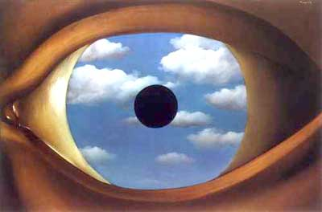 | Rene Magritte (Belgium 1898-1967)  The False Mirror, 1928  magical realism; juxtaposition of normally unrelated objects; the products of our unconscious minds; his work challenged observers’ preconditioned perceptions of reality.

